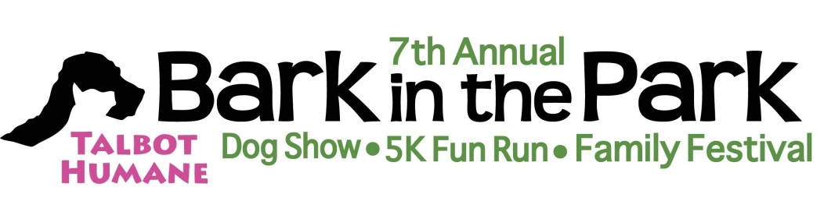
Vendor Application
Saturday, October 8, 2016— 8AM- NOON— Idlewild Park, Easton MD
5K Run/Walk Dog Parade Pomeranian Family Reunion Dog Show
Set up begins at 7 am. Vendors must be ready by 9AM on the event date. Please return application early to guarantee space.
NEW THIS YEAR, 2 OPTIONS FOR VENDORS. PLEASE READ CAREFULLY
If you would like Talbot Humane to provide you a 10x10 space under the tent, providing 2 chairs and 1 table, $125 fee- must reserve this by September 14, 2016.
Businesses which bring their own supplies- tables, chairs, pop-up tent, $40 fee.

Name of Business
Mailing Address
Cell Phone Number
Required Information—Please print clearly
Contact Person Email
Website
Description of Products Being Sold:
We want to be under the tent (MUST SUBMIT BY SEPTEMBER 14, 2016) $125.00
Our Business will supply our own table, chairs and tent $40.00
Total Due:
$
$
$

Disclaimer: All items sold are the sole responsibility of the seller. All licensed business owners are responsible for reporting appropriate taxes. Talbot Humane is not responsible for loss or damage of vendor products or property. Talbot Humane will advertise the event in local and regional publications and through social media. There is no guar- antee of sales volume. No refund of space fees will be given.
Please sign below to complete your application
I have read and fully understand the terms of this application and agree to the disclaimer.

Applicant’s Signature Date

Make checks payable to: Talbot Humane Please mail with this signed form to: Talbot Humane, Attn: Patty Quimby, P.O. Box 1143, Easton, MD 21601.

