**Spay/Neuter Midshore**

**Owner Info:**

Name: ___________________________________________________

Address: _________________________________________________

City: _________________________ Zip: _______

Phone Number: (H) ______________ (C) ______________

**Animal Info:** CAT/DOG

Name: _______________ Sex: M/F Age: _______________

Breed: _____________________ Color: _____________

Vet Name: ______________ Is your animal up to date on vaccines? Y/N

**Free surgery and vaccination program available thanks to funding by:**

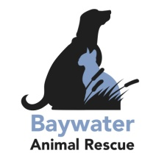

|  |
| --- |
| Office Use:  Income proof:_______________ Vaccines Expiration: Rabies______ Distemper_____  Vet to do surgery: ___________ Appt Date: _____________________  Confirmed: _________________ |